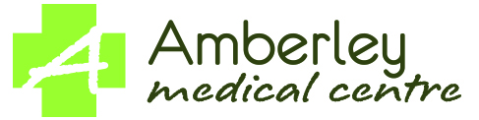
Practice Cleaning Schedule

FREQUENCY | AREAS | ACTIONS | PERSON RESPONSIBLE
Daily | All horizontal surfaces | Damp dust
 | Hard floors | Mop
 | Carpeted floors | Vacuum, preferably using a HEPA filter
 | Toilets and basins, including tap handles | - Clean with diluted bleach, which cleans diarrhoea contamination, norovirus, and C. difficile  - Chlorine bleach degrades microfibre cloths
 | Chairs in waiting room | Damp dust, or vacuum cloth covered seating
 | Any area or surface that is touched routinely (e.g. door handles, reception counter, chair arms) | - Increase the cleaning frequency when there are known outbreaks of concern in the community, and after known high infectious risk patients  - Ideally, use about 70% alcohol or diluted bleach on these high-touch areas
Weekly | Telephone and keyboards | Damp dust
 | Communal children's toy (may require more frequent cleaning as needed) | Clean and disinfect
 | Maintenance of cleaning equipment (e.g., mops, buckets, cleaning rags, filters on vacuum) | - Launder used rags.  - Clean buckets and mop heads with detergent and water, then allow to dry before storing. Mop heads can be autoclaved (if they are not microfibre).  - Change vacuum filters as required or as per indicator.
Monthly | Light fittings | Damp dust
 | Windows and glass partitions | Routinely clean with glass cleaner, then wipe
Yearly | Walls and ceilings | Wipe with hot water and detergent
- Spot clean all areas and objects as necessary, e.g. if visibly soiled or after contact from known high infectious risk patients.
- Start in the cleaner areas, and move on to the dirtier or contaminated areas, e.g. clean toilet areas last.

